SPRING REST – HANDS ON 1 TO 6

Name: Shubham Sangram Bej

Tools Used
- Java 21
- Spring Boot
- Maven
- Spring Web
- Spring Boot DevTools
- Spring XML Configuration
- SLF4J Logging
- IntelliJ IDEA

Hands on 1

Create a Spring Web Project using Maven

Aim
To create a Spring Boot web application using Maven and verify that the application executes successfully.

Procedure
- Created a Spring Boot project using Spring Initializr.
- Selected Maven as the build tool.
- Added Spring Web and Spring Boot DevTools dependencies.
- Opened the project in IntelliJ IDEA.
- Executed the application and verified successful startup.

Files Created
- SpringLearnApplication.java
- pom.xml
- application.properties

Output
The Spring Boot application started successfully without any errors.
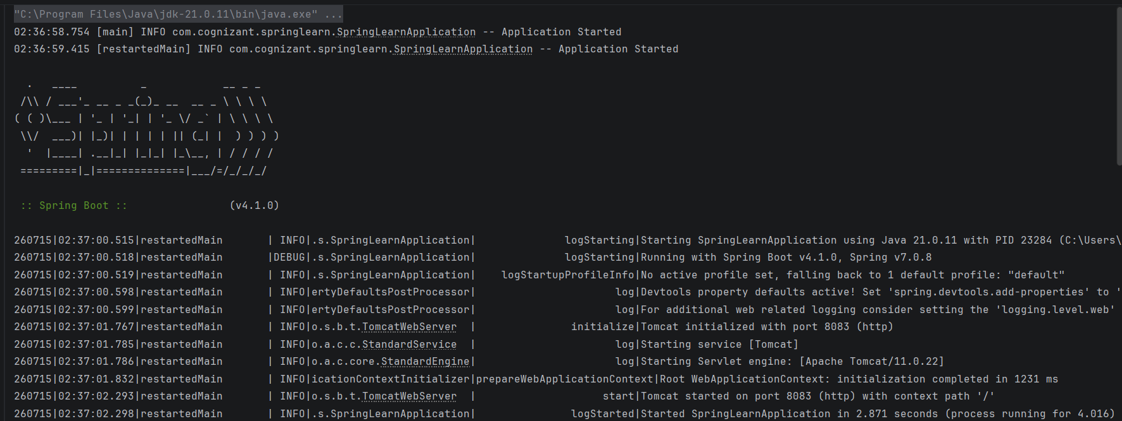

Hands on 2

Load SimpleDateFormat from Spring Configuration XML

Aim
To configure and load a SimpleDateFormat bean using Spring XML configuration.

Procedure
- Created date-format.xml inside the resources folder.
- Configured a SimpleDateFormat bean.
- Loaded the XML configuration using ClassPathXmlApplicationContext.
- Retrieved the bean from the Spring container.
- Parsed the given date successfully.

Files Created
- date-format.xml

Output
The date was successfully parsed using the bean configured in Spring XML.
date-format.xml:
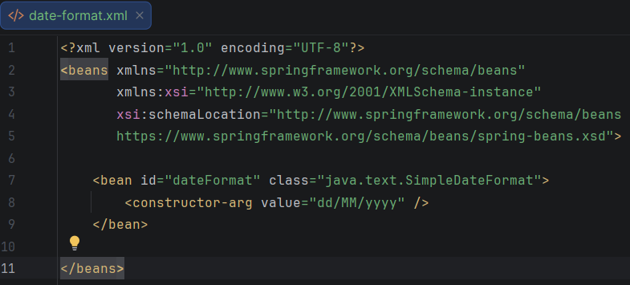
Console Output:
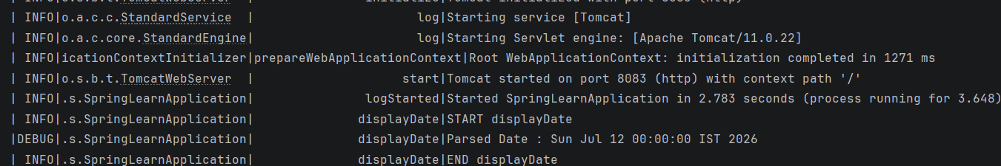

Hands on 3

Incorporate Logging

Aim
To implement logging using the SLF4J framework.

Procedure
- Configured logging in application.properties.
- Created a Logger object.
- Added INFO and DEBUG logs.
- Executed the application.
- Verified the generated log messages.

Files Modified
- application.properties
- SpringLearnApplication.java

Output
Application logs were successfully displayed in the console.
Logger Configuration: (Country.java code)
package com.cognizant.springlearn;
import org.slf4j.Logger;
import org.slf4j.LoggerFactory;
public class Country {
private static final Logger LOGGER = LoggerFactory.getLogger(Country.class);
private String code;
private String name;
public Country() {
LOGGER.debug("Inside Country Constructor.");
}
public String getCode() {
LOGGER.debug("Inside getCode()");
return code;
}
public void setCode(String code) {
LOGGER.debug("Inside setCode()");
this.code = code;
}
public String getName() {
LOGGER.debug("Inside getName()");
return name;
}
public void setName(String name) {
LOGGER.debug("Inside setName()");
this.name = name;
}
@Override
public String toString() {
return "Country [code=" + code + ", name=" + name + "]";
}
}

Console Output:
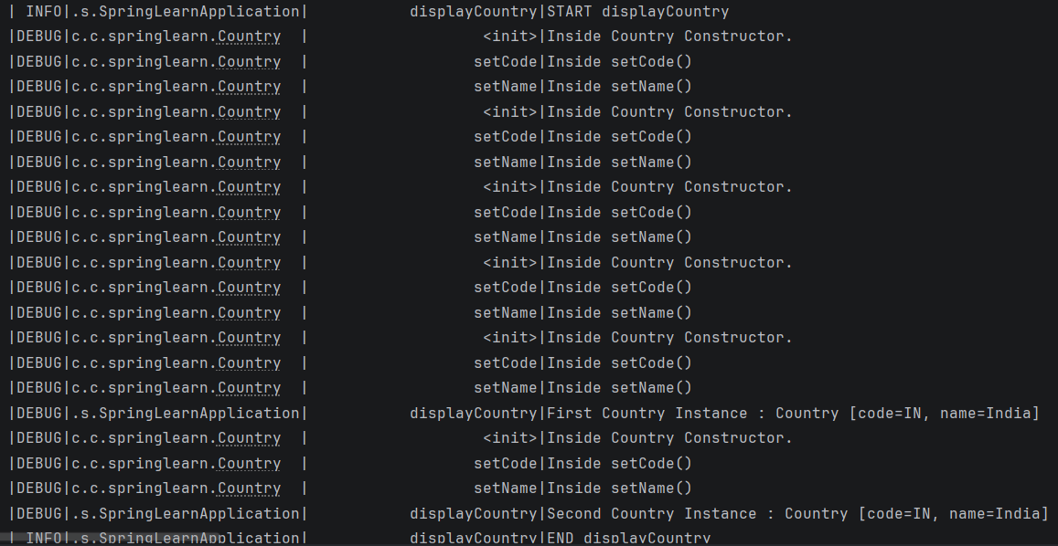

Hands on 4

Load Country from Spring Configuration XML

Aim
To create a Country bean using Spring XML configuration and load it through the Spring IoC Container.

Procedure
- Created the Country class.
- Added constructors, getters and setters.
- Created country.xml.
- Configured the Country bean using setter injection.
- Loaded the bean using ApplicationContext.
- Displayed the Country object.

Files Created
- Country.java
- country.xml

Output
Country bean was successfully created and loaded using Spring XML configuration.

country.xml:
<?xml version="1.0" encoding="UTF-8"?>
<beans xmlns="http://www.springframework.org/schema/beans"
xmlns:xsi="http://www.w3.org/2001/XMLSchema-instance"
xsi:schemaLocation="http://www.springframework.org/schema/beans
https://www.springframework.org/schema/beans/spring-beans.xsd">
<!-- Hands-on 4 & 5: Country Bean (Change scope to "singleton" to see constructor called once) -->
<bean id="country" class="com.cognizant.springlearn.Country" scope="prototype">
<property name="code" value="IN" />
<property name="name" value="India" />
</bean>
<!-- Additional countries for the list -->
<bean id="us" class="com.cognizant.springlearn.Country">
<property name="code" value="US" />
<property name="name" value="United States" />
</bean>
<bean id="de" class="com.cognizant.springlearn.Country">
<property name="code" value="DE" />
<property name="name" value="Germany" />
</bean>
<bean id="jp" class="com.cognizant.springlearn.Country">
<property name="code" value="JP" />
<property name="name" value="Japan" />
</bean>
<!-- Hands-on 6: List of Countries -->
<bean id="countryList" class="java.util.ArrayList">
<constructor-arg>
<list>
<ref bean="country" />
<ref bean="us" />
<ref bean="de" />
<ref bean="jp" />
</list>
</constructor-arg>
</bean>
</beans>

Console Output:
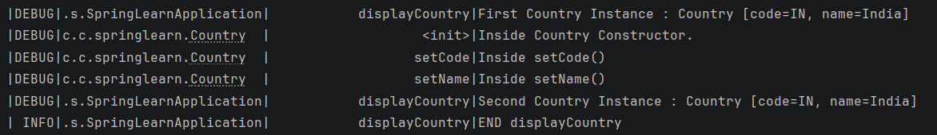

Hands on 5

Demonstration of Singleton and Prototype Scope

Aim
To understand the difference between Singleton and Prototype bean scopes.

Procedure
- Configured the Country bean using Singleton scope.
- Executed the application and observed object creation.
- Changed the bean scope to Prototype.
- Executed the application again.
- Compared the results.

Observation
- Singleton scope creates only one object.
- Prototype scope creates a new object every time the bean is requested.

Output
Successfully demonstrated the behaviour of Singleton and Prototype scopes.
Singleton Configuration:
<bean id="country" class="com.cognizant.springlearn.Country" scope="singleton">
<property name="code" value="IN" />
<property name="name" value="India" />
</bean>

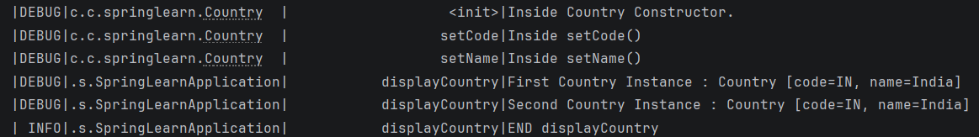

Prototype Configuration:
<bean id="country" class="com.cognizant.springlearn.Country" scope="prototype">
<property name="code" value="IN" />
<property name="name" value="India" />
</bean>


Hands on 6

Load List of Countries from Spring Configuration XML

Aim
To configure and retrieve a list of Country objects using Spring XML.

Procedure
- Created multiple Country beans.
- Added all Country beans into a List bean.
- Retrieved the List bean from the Spring container.
- Displayed all Country objects.

Files Modified
- country.xml

Output
List of Country objects was successfully retrieved and displayed.
country.xml (List Configuration)
<bean id="us" class="com.cognizant.springlearn.Country">
<property name="code" value="US" />
<property name="name" value="United States" />
</bean>
<bean id="de" class="com.cognizant.springlearn.Country">
<property name="code" value="DE" />
<property name="name" value="Germany" />
</bean>
<bean id="jp" class="com.cognizant.springlearn.Country">
<property name="code" value="JP" />
<property name="name" value="Japan" />
</bean>
<!-- Hands-on 6: List of Countries -->
<bean id="countryList" class="java.util.ArrayList">
<constructor-arg>
<list>
<ref bean="country" />
<ref bean="us" />
<ref bean="de" />
<ref bean="jp" />
</list>
</constructor-arg>
</bean>

Console Output:
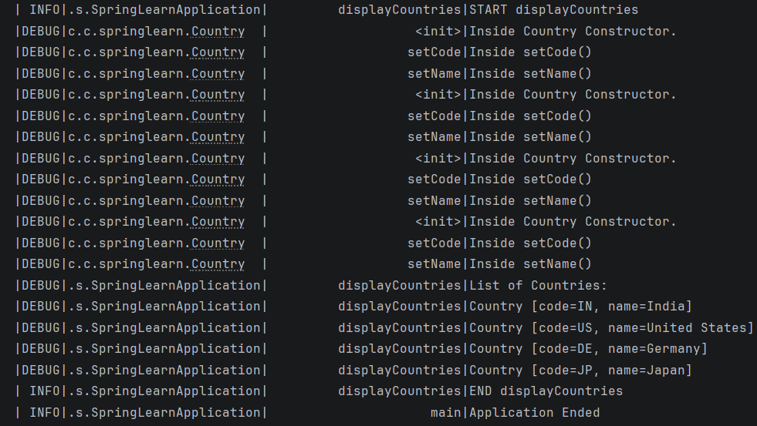

Conclusion
Successfully completed Hands on 1 to Hands on 6 of Spring REST. The exercises provided practical knowledge of Spring Boot project creation, XML-based bean configuration, dependency injection, logging using SLF4J, bean scopes, and collection injection. These concepts form the foundation for developing Spring Framework applications and will be useful in the upcoming REST and Spring Boot hands-on exercises.

